Attendees:
- Tim O
- Shannon R
- Bill P
- Bob S
Machine Type
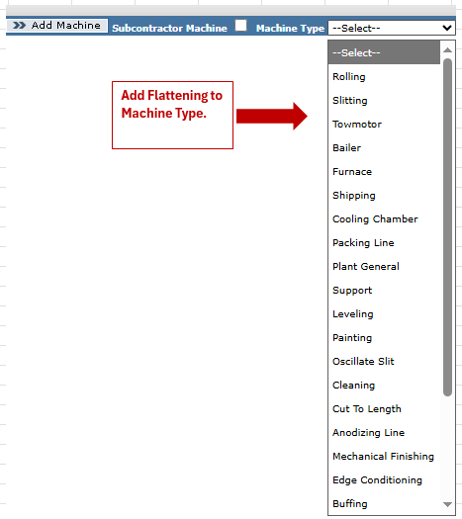
FL1/FL2/FL3 must be added as new machines so that they appear in the “Select a Machine” dropdown. Asset Short descriptions shall be Flattening Line 1, Flattening Line 2, & Flattening Line 3.
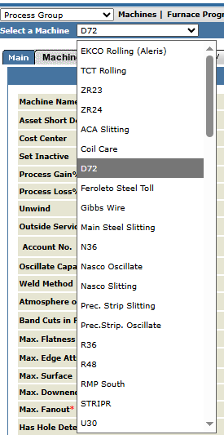

Tabs needed for each Flattening Line: Main, Roll Finish, Pass Schedule, Coating, KSI/Guage Max Cuts, Rewind Capabilities, ID Width Max Cuts, Setup/Handling Times, Tooling Inventory, Speed, Material Loss, History.

The Main tab (Machine Properties) should be copied from the slitter template and then will keep the following rows, including additional rows from the Mill Template.
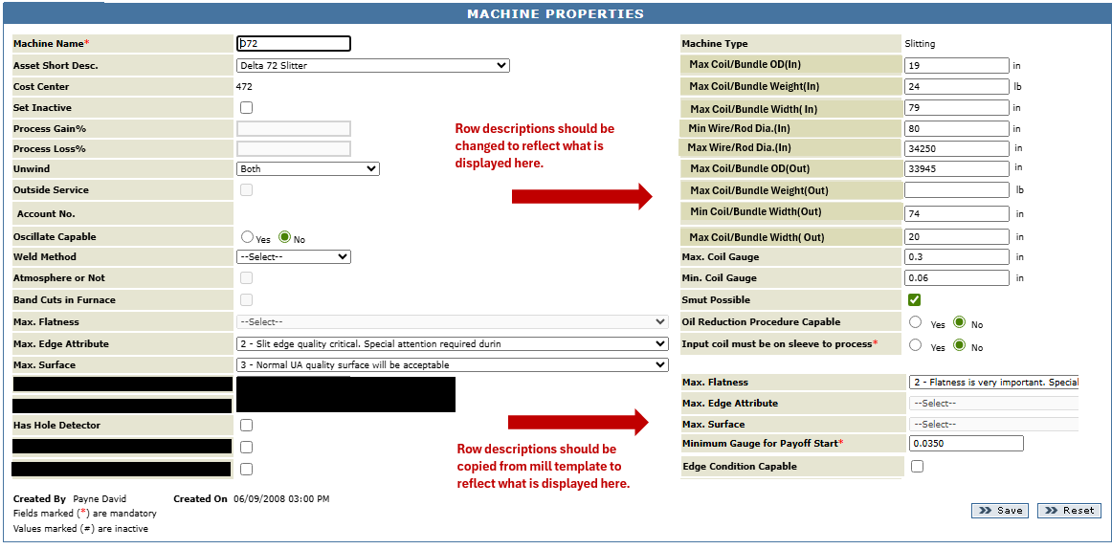
The Roll Finish tab should be copied completely from the mill template.

The Pass Schedule should be copied completely from the mill template. Everything current is applicable to Flattening Lines.

The “Mill Schedule” button should be changed to “Flattening Line Schedule”. The window header should also reflect this change. All fields will remain relevant for the new process.
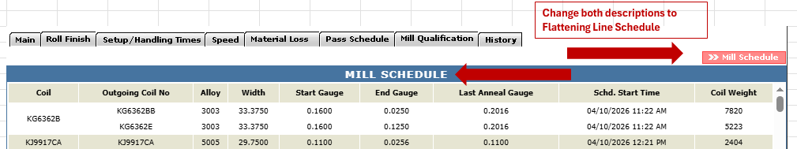
The Coating tab should be copied completely from the slitter template.
The KSI/Gauge Max Cuts tab should be copied from the slitter template.
  - But without max # of cuts
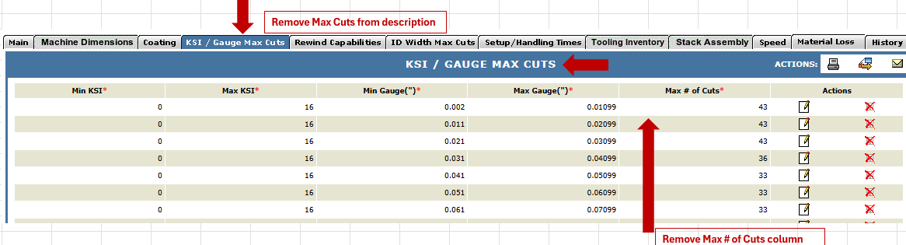
Rewind capabilities tab should be copied completely from the slitter template.
  - Will need this for future applications
ID Width Max Cuts tab should be copied from the slitter template.
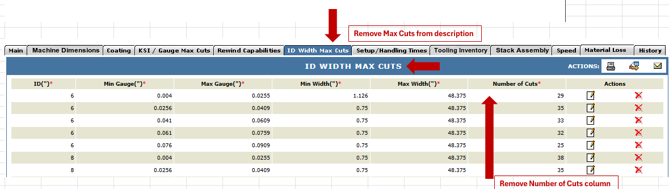
Setup/Handling Times tab should be copied completely from the slitter template.
  - Naj/Bob/Tim are building a standards spec spreadsheet that will be used for this template that will be like the Slitter Template. The layout can be adjusted once this has been completed. We will use the spreadsheet to build out FL attributes
Tooling Inventory tab should be copied completely from the slitter template.
  - Dies & Edgers will be added as tooling. Tim will create a profile sheet for each tooling-type that can be added to the dropdown menu and layouts.

Speed tab should be copied from the mill template. Columns shown below are the only ones needed, and change “Min/Max Gauge” to “Min Gauge/Diameter” and “Max Gauge/Diameter”. To the right of “Sleeve Insert”, add checkboxes for DB1, DB2, FM1-S1, FM2-S1, FM2-S2 and FM2-S3. User can select/deselect the checkboxes to indicate if that component is active/inactive (running or not running) and the values in remaining columns could be defined accordingly. So, an alloy – width – gauge/diameter combination could have multiple rows depending on the selection of these checkboxes.
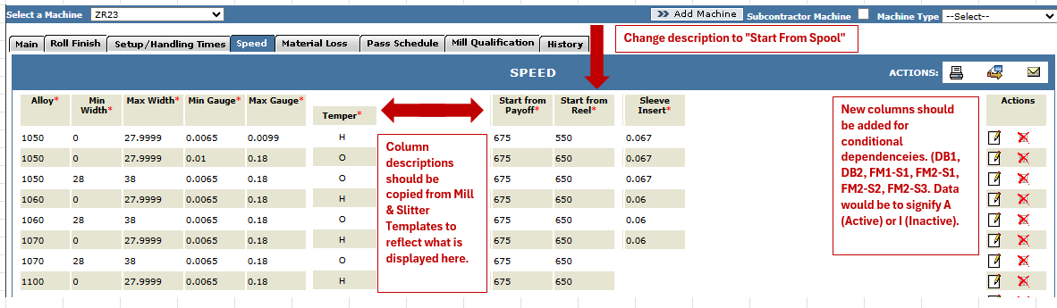
Material Loss tab should be copied from the mill template, but the fields within it are yet to be defined.
  - Like the mill, scrap calculation will be scenario based but scaled in footage not weight. A profile will have to be built with the correct terminology for the layout and appended later.
History tab should be copied form the mill template but will share some attributes with the slitter template.

